**Topic-1: Introduction to NLP**

What is NLP?

NLP stands for **Natural Language Processing**, which is a part of **Computer Science, Human language,** and **Artificial Intelligence**. It is the technology that is used by machines to understand, analyze, manipulate, and interpret human's languages. It helps developers to organize knowledge for performing tasks such as **translation, speech recognition, relationship extractionetc**

**APPLICATIONS OF NLP:**

1.**SPEECH RECOGNITION**: Speech recognition is used for converting spoken words into text. It is used in applications, such as mobile, home automation, video recovery, dictating to Microsoft Word, voice biometrics, voice user interface, and so on.

(EX:GOOGLE ASSIST,SIRI)

2. **SENTIMENTAL ANALYSIS**:Sentiment Analysis is also known as **opinion mining**. It is used on the web to analyze the attitude, behavior, and emotional state of the sender. This application is implemented through a combination of NLP (Natural Language Processing) and statistics by assigning the values to the text (positive, negative, or natural)

* *“I really like the new design of your website!”* → Positive
* *“I’m not sure if I like the new design”* → Neutral
* *“The new design is awful!”* → Negative

***Examples:***

* Social media monitoring.
* Brand monitoring.
* Customer support analysis.
* Customer feedback analysis.
* Market research.

3. **MACHINE TRANSLATIONS:**Machine translation is used to translate text or speech from one natural language to another natural language.(ex: Google translator)

4. **CHAT BOTS:**Question Answering focuses on building systems that automatically answer the questions asked by humans in a natural language

**Components of NLP**

## INPUT🡪 SPEECH RECOGNITION 🡪NLU🡪NLG🡪OUTPUT

**1. Natural Language Understanding (NLU)**

Natural Language Understanding (NLU) helps the machine to understand and analyze human language by extracting the metadata from content such as concepts, entities, keywords, emotion, relations, and semantic roles.

NLU mainly used in Business applications to understand the customer's problem in both spoken and written language.

NLU involves the following tasks -

* It is used to map the given input into useful representation.
* It is used to analyze different aspects of the language.

## CHALLANGES for NLU:

## Lexical Ambiguity: Lexical Ambiguity exists in the presence of two or more possible meanings of the sentence within a single word.

**Example:** Manya is looking for a **match**.

In the above example, the word match refers to that either Manya is looking for a partner or Manya is looking for a match. (Cricket or other match)

1. **Syntactic Ambiguity:** Syntactic Ambiguity exists in the presence of two or more possible meanings within the sentence.

**Example:** I saw the girl with the binocular.

In the above example, did I have the binoculars? Or did the girl have the binoculars?

## 3. Semantic Ambiguity: when you are referring to something using the pronoun.

## ****Example:****The car hit the pole while it is moving

## ****In the above example ,”it “refers to car or pole****

## 4. Pragmatic Ambiguity: The police are coming

**2. Natural Language Generation (NLG)**

Natural Language Generation (NLG) acts as a translator that converts the computerized data into natural language representation. It mainly involves Text planning, Sentence planning, and deals with structured data.

**Topic-2: Steps in NLP**

There are general five steps −

* **Lexical Analysis** − It involves identifying and analyzing the structure of words. Lexicon of a language means the collection of words and phrases in a language. Lexical analysis is dividing the whole chunk of txt into paragraphs, sentences, and words.
* **Syntactic Analysis (Parsing)** − It involves analysis of words in the sentence for grammar and arranging words in a manner that shows the relationship among the words. The sentence such as “The school goes to boy” is rejected by English syntactic analyzer.

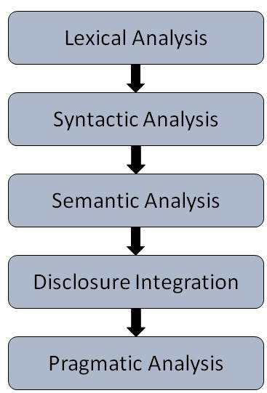

* **Semantic Analysis** − It draws the exact meaning or the dictionary meaning from the text. The text is checked for meaningfulness. It is done by mapping syntactic structures and objects in the task domain. The semantic analyzer disregards sentence such as “hot ice-cream”.
* **Discourse Integration** − The meaning of any sentence depends upon the meaning of the sentence just before it. In addition, it also brings about the meaning of immediately succeeding sentence.
* **Pragmatic Analysis** − During this, what was said is re-interpreted on what it actually mean-t. It involves deriving those aspects of language which require real world knowledge.

**Topic-3: SYNTACTIC PROCESSING**

Syntactic analysis or parsing or syntax analysis is the third phase of NLP. The purpose of this phase is to draw exact meaning, or you can say dictionary meaning from the text. Syntax analysis checks the text for meaningfulness comparing to the rules of formal grammar. For example, the sentence like “hot ice-cream” would be rejected by semantic analyzer.

In this sense, syntactic analysis or parsing may be defined as the process of analyzing the strings of symbols in natural language conforming to the rules of formal grammar

**3.1 Concept of Parser**

It is used to implement the task of parsing. It may be defined as the software component designed for taking input data (text) and giving structural representation of the input after checking for correct syntax as per formal grammar. It also builds a data structure generally in the form of parse tree or abstract syntax tree or other hierarchical structure.

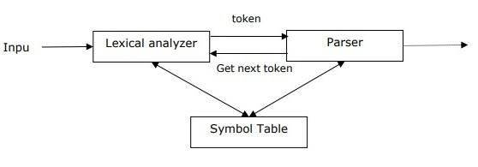

The main roles of the parse include −

* To report any syntax error.
* To recover from commonly occurring error so that the processing of the remainder of program can be continued.
* To create parse tree.
* To create symbol table.
* To produce intermediate representations (IR).

GENERAL EXAMPLE FOR PARSING A TREE:

a * b + c

* Step 1:

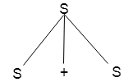

* Step 2:

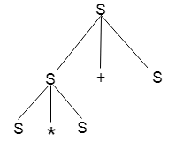

* Step 3:

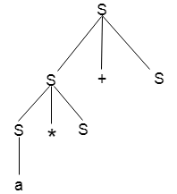

* Step 4:

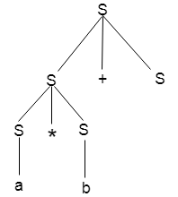

* Step 5:

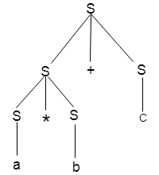

**Types of Parsing**

Derivation divides parsing into the followings two types −

* Top-down Parsing
* Bottom-up Parsing

**Top-down Parsing**

In this kind of parsing, the parser starts constructing the parse tree from the start symbol and then tries to transform the start symbol to the input. The most common form of topdown parsing uses recursive procedure to process the input. The main disadvantage of recursive descent parsing is backtracking.

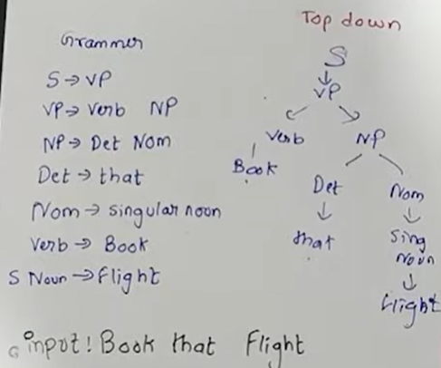

**Bottom-up Parsing**

In this kind of parsing, the parser starts with the input symbol and tries to construct the parser tree up to the start symbol.

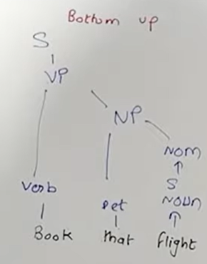

**Concept of Derivation**

In order to get the input string, we need a sequence of production rules. Derivation is a set of production rules.

**Types of Derivation**

**Left-most Derivation**

In the left-most derivation, the sentential form of an input is scanned and replaced from the left to the right. The sentential form in this case is called the left-sentential form.

a+b*c

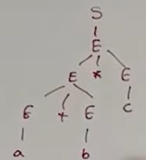

1. S = S + S
2. S = S - S
3. S = a | b |c

INPUT: a - b + c

1. S = S + S
2. S = S - S + S
3. S = a - S + S
4. S = a - b + S
5. S = a - b + c

**Right-most Derivation**

In the left-most derivation, the sentential form of an input is scanned and replaced from right to left. The sentential form in this case is called the right-sentential form.

INPUT: a - b + c

1. S = S - S
2. S = S - S + S
3. S = S - S + c
4. S = S - b + c
5. S = a - b + c

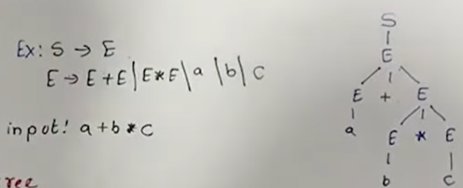

**3.2 Grammar**

Grammar is defined as the rules for forming well-structured sentences.

While describing the syntactic structure of well-formed programs, Grammar plays a very essential and important role. In simple words, Grammar denotes syntactical rules that are used for conversation in natural languages.

Syntactic categories (common denotations) in NLP

* np - noun phrase
* vp - verb phrase
* s - sentence
* det - determiner (article)
* n - noun
* tv - transitive verb (takes an object)
* iv - intransitive verb
* prep - preposition
* pp - prepositional phrase
* adj - adjective

Mathematically, a grammar G can be written as a 4-tuple (N, T, S, P) where,

**N or VN =** set of non-terminal symbols, or variables.

**T or ∑ =** set of terminal symbols.

**S =** Start symbol where S ∈ N

**P =**Production rules for Terminals as well as Non-terminals.

It has the form α → β, where α and β are strings on **VN ∪ ∑** and at least one symbol of α belongs to VN

## Types of Grammar in NLP

**(a) Context Free Grammar**

A context free grammar (CFG) is a formal grammar which is used to generate all the possible patterns of strings in a given formal language.

It is defined as four tuples −

**G=(V,T,P,S)**

* G is a **grammar**, which consists of a set of production rules. It is used to generate the strings of a language.
* T is the final set of **terminal symbols**. It is denoted by lower case letters.
* V is the final set of **non-terminal symbols.** It is denoted by capital letters
* P is a set of **production rules,** which is used for replacing non-terminal symbols (on the left side of production) in a string with other terminals (on the right side of production).
* S is the **start symbol** used to derive the string

A *context-free grammar (CFG)* is a list of rules that define the set of all well-formed sentences in a language. Each rule has a left-hand side, which identifies a syntactic category, and a right-hand side, which defines its alternative component parts, reading from left to right.

**E.g.,** the rule s --> np vp means that "a sentence is defined as a noun phrase followed by a verb phrase."

Figure 1 shows a simple CFG that describes the sentences from a small subset of English.

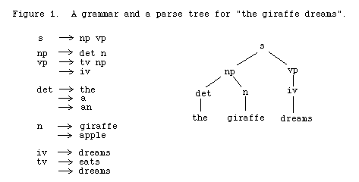

**(B) Constituency Grammar**

**Constituents** are groups of words behaving as single units and consist of phrases, words, or morphemes, including:

|  |  |  |
| --- | --- | --- |
| **Symbol** | **Type** | **Example** |
| NP | Noun Phrases | "he," "the boy," "the man with the old black shoes" |
| VP | Verb Phrases | "walked," "sit down and be quiet" |
| PP | Prepositional Phrases | "on the floor," "with the paper," "apart from everything said before." |

**Constituency grammar** is drawn from a set of languages called context-free languages (CFL) and consists of a set of rules or productions stating how a constituent can be segmented into smaller constituents, up to the level of individual words.

Constituency grammar is defined by four parameters:

* A set of **non-terminals** (aka variables), each denoting a set of strings.
* A finite set of **terminal** symbols (lexicon), constituting the alphabet of the language considered.
* A non-terminal **starting symbol**.
* A list of rules called **productions** that recursively define the structure of the language. Each rule has the form A → s, where:  
  1) "A" is a non-terminal (variable) symbol on the left-hand side of the rule.  
  2) "s" is a sequence of terminals and non-terminals that might be empty

|  |  |  |
| --- | --- | --- |
| **Grammar**  **Rule / Production** | **Description** | **Example** |
| S → NP + VP | A sentence can be composed of Noun Phrase + Verb Phrase | I + want a vacation. |
| NP → Pronoun | A Noun Phrase can be composed of a Pronoun | I |
| NP → Proper-Noun | A Noun Phrase can be composed of a proper noun | Las Vegas |
| NP → Det Nominal | A Noun Phrase can be composed of a determiner (Det) followed by a Nominal | a + knight |
| Nominal → Nominal Noun | A Nominal may consist of one or more Nouns | morning + flight |
| PP → Preposition NP | A Preposition Phrase can be composed of a preposition followed by a Noun Phrase | from + Las Vegas |
| VP → Verb | Verb Phrase | make |
| VP → Verb NP | A Verb Phrase can be composed of a verb and a Noun Phrase | book + a flight |
| VP → Verb NP PP | A Verb Phrase can be composed of a verb followed by a Noun Phrase and a Preposition Phrase | book + a flight + in the evening |
| VP → Verb PP | A Verb Phrase can be composed of a verb and a Preposition Phrase | eating + in the evening |

Constituency grammar is widely used in compilers and helps in building phrase structure trees or parse trees.

Let us consider the following sentence: "The man eats the apple."

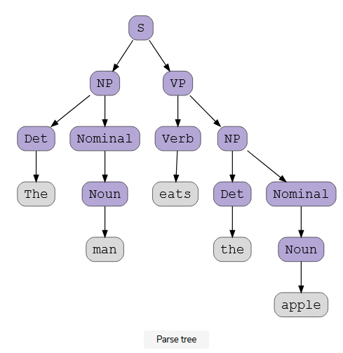

**Topic-4: Semantic Analysis**

Semantic Analysis is a subfield of Natural Language Processing (NLP) that attempts to understand the meaning of Natural Language. Understanding Natural Language might seem a straightforward process to us as humans. However, due to the vast complexity and subjectivity involved in human language, interpreting it is quite a complicated task for machines. Semantic Analysis of Natural Language captures the meaning of the given text while taking into account context, logical structuring of sentences and grammar roles.

**Parts of Semantic Analysis**

Semantic Analysis of Natural Language can be classified into two broad parts:

**1. Lexical Semantic Analysis:**Lexical Semantic Analysis involves understanding the meaning of each word of the text individually. It basically refers to fetching the dictionary meaning that a word in the text is deputed to carry.

**2. Compositional Semantics Analysis:** Although knowing the meaning of each word of the text is essential, it is not sufficient to completely understand the meaning of the text.

For example, consider the following two sentences:

* **Sentence 1:** I like you.
* **Sentence 2:** you like me.

Although both these sentences 1 and 2 same,but, they convey entirely different meanings.

In sentence 1 **I** is **subject** and **you** is **object**

In sentence 2 **you** is **subject** and **me** is **object**

Hence, under Compositional Semantics Analysis, we try to understand how combinations of individual words form the meaning of the text.

**4.1 Tasks involved in Semantic Analysis**

In order to understand the meaning of a sentence, the following are the major processes involved in Semantic Analysis:

1. Word Sense Disambiguation
2. Relationship Extraction

**Word Sense Disambiguation:**

In Natural Language, the meaning of a word may vary as per its usage in sentences and the context of the text. Word Sense Disambiguation involves interpreting the meaning of a word based upon the context of its occurrence in a text.

For example, the word ‘Bark’ may mean ‘the sound made by a dog’ or ‘the outermost layer of a tree.’

Likewise, the word ‘rock’ may mean ‘*a stone*‘ or ‘*a genre of music*‘ – hence, the accurate meaning of the word is highly dependent upon its context and usage in the text.

Thus, the ability of a machine to overcome the ambiguity involved in identifying the meaning of a word based on its usage and context is called Word Sense Disambiguation.

**Relationship Extraction:**

Another important task involved in Semantic Analysis is Relationship Extracting. It involves firstly identifying various entities present in the sentence and then extracting the relationships between those entities.

For example, consider the following sentence:

**Sita is a student studying in college.**

The entities involved in this text, along with their relationships, are shown below.

Sita is a student Studying in College

Entity relationship Entity relationship Entity

**4.2 Elements of Semantic Analysis**

Some of the critical elements of Semantic Analysis that must be scrutinized and taken into account while processing Natural Language are:

* **Hyponymy:** Hyponymys refers to a term that is an instance of a generic term. They can be understood by taking class-object as an analogy. For example: ‘*Color*‘ is a hypernymy while ‘*grey*‘, ‘*blue*‘, ‘*red*‘, etc, are its hyponyms.
* **Homonymy:** Homonymy refers to two or more lexical terms with the same spellings but completely distinct in meaning. For example: ‘*Rose*‘ might mean ‘*the past form of rise*‘ or ‘*a flower*‘, – same spelling but different meanings; hence, ‘*rose*‘ is a homonymy.
* **Synonymy:**When two or more lexical terms that might be spelt distinctly have the same or similar meaning, they are called Synonymy. For example: *(Job, Occupation), (Large, Big), (Stop, Halt).*
* **Antonymy:**Antonymy refers to a pair of lexical terms that have contrasting meanings – they are symmetric to a semantic axis. For example: *(Day, Night), (Hot, Cold), (Large, Small).*
* **Polysemy:** Polysemy refers to lexical terms that have the same spelling but multiple closely related meanings. It differs from homonymy because the meanings of the terms need not be closely related in the case of homonymy. For example: ‘*man*‘ may mean ‘*the human species*‘ or ‘*a male human*‘ or ‘*an adult male human*‘ – since all these different meanings bear a close association, the lexical term ‘*man*‘ is a polysemy.
* **Meronomy:**Meronomy refers to a relationship wherein one lexical term is a constituent of some larger entity. For example: ‘*Wheel*‘ is a meronym of ‘*Automobile*‘

**4.3 Meaning Representation**

While, as humans, it is pretty simple for us to understand the meaning of textual information, it is not so in the case of machines. Thus, machines tend to represent the text in specific formats in order to interpret its meaning. This formal structure that is used to understand the meaning of a text is called meaning representation.

**Basic Units of Semantic System:**

In order to accomplish Meaning Representation in Semantic Analysis, it is vital to understand the building units of such representations. The basic units of semantic systems are explained below:

1. **Entity:** An entity refers to a particular unit or individual in specific such as a person or a location.  For example sita, Delhi, etc.
2. **Concept:**A Concept may be understood as a generalization of entities. It refers to a broad class of individual units. For example college, City, Students, human etc
3. **Relations:**Relations help establish relationships between various entities and concepts. For example: ‘Sita is a student, ‘Delhi is a City.’, etc.
4. **Predicate:** Predicates represent the verb structures of the sentences.

In Meaning Representation, we employ these basic units to represent textual information.

**Approaches to Meaning Representations:**

Now that we are familiar with the basic understanding of Meaning Representations, here are some of the most popular approaches to meaning representation:

1. First-order predicate logic (FOPL)
2. Semantic Nets
3. Frames
4. Conceptual dependency (CD)
5. Rule-based architecture
6. Case Grammar
7. Conceptual Graphs

**4.4 Semantic Analysis Techniques**

Based upon the end goal one is trying to accomplish, Semantic Analysis can be used in various ways. Two of the most common Semantic Analysis techniques are:

**Text Classification**

In-Text Classification, our aim is to label the text according to the insights we intend to gain from the textual data.

For example:

* In **Sentiment Analysis,** we try to label the text with the prominent emotion they convey. It is highly beneficial when analyzing customer reviews for improvement.
* In **Topic Classification**, we try to categories our text into some predefined categories. For example: Identifying whether a research paper is of Physics, Chemistry or Maths
* In **Intent Classification**, we try to determine the intent behind a text message. For example: Identifying whether an e-mail received at customer care service is a query, complaint or request.

**Text Extraction**

In-Text Extraction, we aim at obtaining specific information from our text.

For Example,

* In **Keyword Extraction**, we try to obtain the essential words that define the entire document.
* In **Entity Extraction**, we try to obtain all the entities involved in a document.

**Significance of Semantics Analysis**

Semantics Analysis is a crucial part of Natural Language Processing (NLP). In the ever-expanding era of textual information, it is important for organizations to draw insights from such data to fuel businesses. Semantic Analysis helps machines interpret the meaning of texts and extract useful information, thus providing invaluable data while reducing manual efforts.

Besides, Semantics Analysis is also widely employed to facilitate the processes of automated answering systems such as chatbots – that answer user queries without any human interventions.

**Topic-5: Transition Network**

* It is a method to represent the natural languages. It is based on applications of directed graphs and finite state automata.
* The transition network can be constructed by the help of some inputs, states and outputs.
* A transition network may consist of some states or nodes, some labeled arcs from one state to the next state through which it will move.
* The arc represents the rule or some conditions upon which the transition is made from one state to another state.
* For example, a transition network is used to recognize a sentence consisting of an article, a noun, an auxiliary, a verb, an article, a noun would be represented by the transition network as follows.

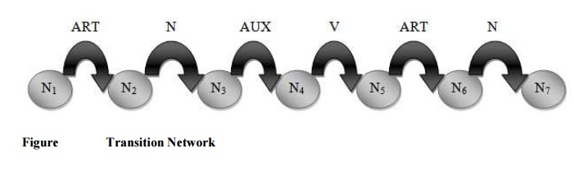

* The transition from N1 to N2 will be made if an article is the first input symbol. If successful, state N2 is entered.
* The transition from N2 to N3 can be made if a noun is found next. If successful, state N3 is entered.
* The transition from N3 to N4 can be made if an auxiliary is found and so on.

Suppose consider a sentence **“A boy is eating a banana**”.

So if the sentence is parsed in the above transition network then, first ‘A’ is an article.

So successful transition to the node N1 to N2.

Then boy is a noun (so N2 to N3),

“is” is an auxiliary (N5 to N6) and finally “banana” is a noun (N 6 to N7) is done successfully.

So the above sentence is successfully parsed in the transition network.

**TYPES OF TRANSITION NETWORK**

 There are generally two types of transition networks like

1.     Recursive Transition networks (RTN)

2.     Augmented Transition networks (ATN).

**5.1. Recursive Transition Networks (RTN)**

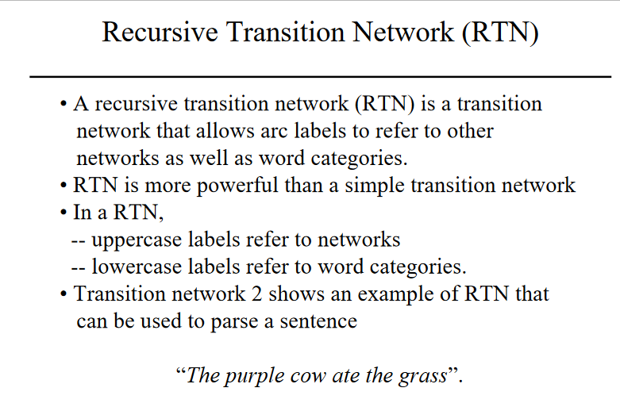

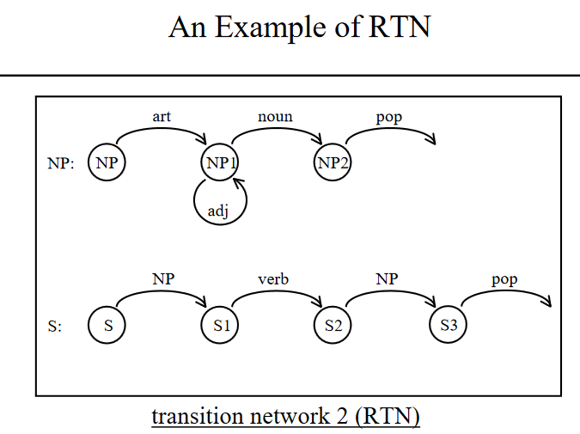

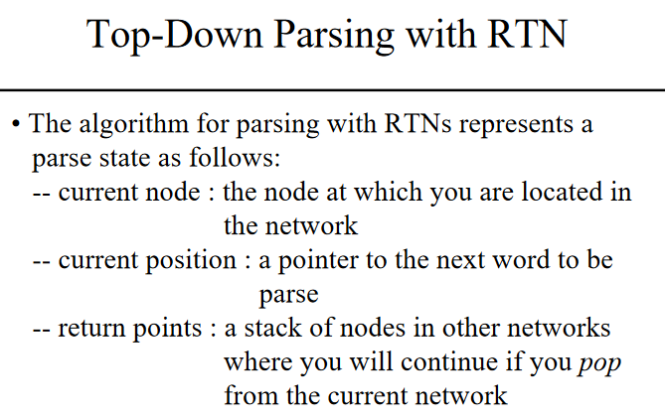

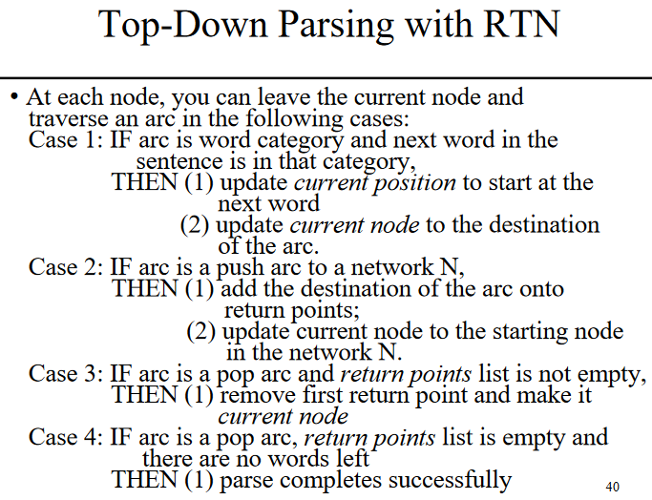

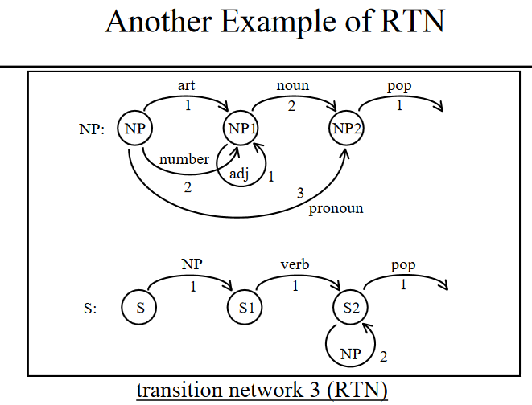

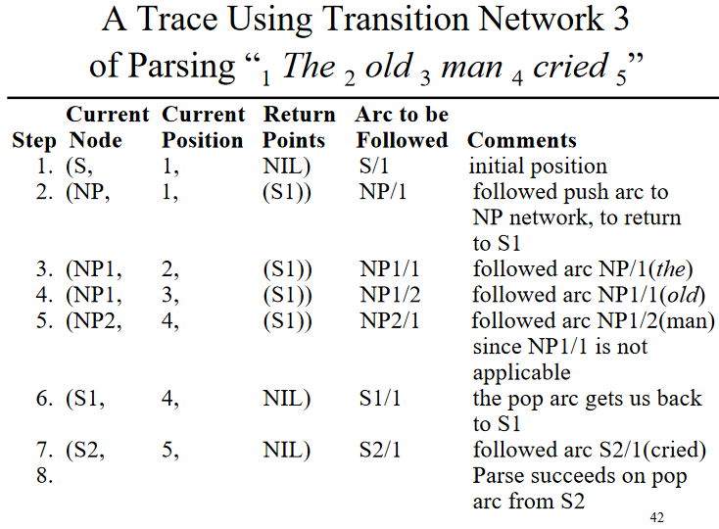

**5.2. Augmented Transition Network (ATN)**

* An ATN is a modified transition network. It is an extension of RTN.
* An augmented transition network (ATN) is a recursive transition network that can perform tests and take actions during arc transitions.

An augmented transition network (ATN) is an RTN that has been extended in three ways:

1. A set of **registers** has been added; these can be used to store information, such as partially formed derivation trees, between jumps to different subnetworks.
2. Arcs, can have arbitrary **tests** associated with them that must be satisfied before the arc is taken.
3. Certain **actions** may be "attached" to an arc, to be executed whenever it is taken (usually to modify the data structure returned).

* The operation of an ATN is similar to that of an RTN except that if an arc has a test, then the test is performed first and the arc is taken only if the test is successful.
* Also if an arc has actions associated with it, then these operations are performed after following the arc.
* ATNs are capable of building deep structure descriptions of a sentence in an efficient manner.
* The ATN collects the sentence features for further analysis.
* The additional features that can be captured by the ATN are; **subject NP**, the **object NP**, the **subject verb** agreement, the **declarative** or i**nterrogative** mood, **tense** and so on.
* The ATN represents sentence structure by using a slot filter representation, which reflects more of the functional role of phrases in a sentence.
* For example, one noun phrase may be identified as “subject” (SUBJ) and another as the “object” of the verb. Within noun phrases, parsing will also identify the determiner structure, adjectives, the noun etc.

For the sentence **“Ram ate an apple”,** we can represent as in figure.

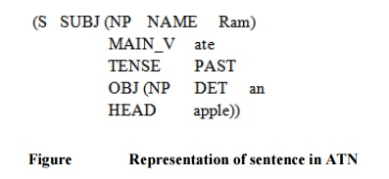

* The ATN maintains the information by having various registers like **DET, ADJ and HEAD** etc.
* Registers are set by actions that can be specified on the arcs.
* When the arc is followed, the specified action associated with it is executed.
* An ATN can recognize any language that a general purpose computer can recognize.
* The ATNs have been used successfully in a number of natural language systems as well as front ends for databases and expert systems.

**Topic-6: Natural Language Understanding (NLU)**

Natural Language Understanding (NLU) is the ability of a computer to understand human language. You can use it for many applications, such as chatbots, voice assistants, and automated translation services.

The most basic form of NLU is parsing, which takes text written in natural language and converts it into a structured format that computers can understand.

For example, the words "hello world" would be converted into their respective parts of speech (nouns and verbs), while "I am hungry" would be split into two sentences: "I am" and "hungry."

Parsing is only one part of NLU; other tasks include sentiment analysis, entity recognition, and semantic role labeling.

Natural language understanding is taking in an input text string and analyzing what it means. It can happen on a small scale.

For example, when a human reads a user's question on Twitter and replies with an answer, or on a large scale, like when Google parses millions of documents to figure out what they're about.

Natural language processing is the process of turning human-readable text into computer-readable data. It's used in everything from online search engines to chatbots that can understand our questions and give us answers based on what we've typed.

**How Does Natural Language Understanding Work?**

Natural language understanding is taking a natural language input, like a sentence or paragraph, and processing it to produce an output. It's often used in consumer-facing applications like web search engines and chatbots, where users interact with the application using plain language.

You can break down the process into three stages:

* Tokenization: The first stage of NLU involves splitting a given input into individual words or tokens. It includes punctuation, other symbols, and words from all languages.
* Lexical Analysis: Next, the tokens are placed into a dictionary that includes their part of speech (for example, whether they're nouns or verbs). It also includes identifying phrases that should be placed in a separate database for later use.
* Syntactic Analysis: The tokens are analyzed for their grammatical structure. It includes identifying each word's roles and whether there's any ambiguity between multiple interpretations of those roles.

## Importance of Natural Language Understanding

Natural language understanding is the process of identifying the meaning of a text, and it's becoming more and more critical in business. Natural language understanding software can help you gain a competitive advantage by providing insights into your data that you never had access to before.

When you're analyzing data with natural language understanding software, you can find new ways to make business decisions based on the information you have.

For instance, you are an online retailer with data about what your customers buy and when they buy them.

Using a natural language understanding software will allow you to see patterns in your customer's behavior and better decide what products to offer them in the future.

Companies can also use natural language understanding software in marketing campaigns by targeting specific groups of people with different messages based on what they're already interested in. It can even predict what those people will want next.

## Natural Language Understanding Applications

### a) IVR and Message Routing

Answering customer calls and directing them to the correct department or person is an everyday use case for NLUs. Implementing an IVR system allows businesses to handle customer queries 24/7 without hiring additional staff or paying for overtime hours.

### b) Data Capture

A data capture application will enable users to enter information into fields on a web form using natural language pattern matching rather than typing out every area manually with their keyboard. It makes it much quicker for users since they don't need to remember what each field means or how they should fill it out correctly with their keyboard (e.g., date format).

### c) Customer Support

Customer support agents can leverage NLU technology to gather information from customers while they're on the phone without having to type out each question individually.

Agents can also help customers with more complex issues by using NLU technology combined with natural language generation tools to create personalized responses based on specific information about each customer's situation.

### d) Chatbots

A [chatbot](https://www.simplilearn.com/how-to-build-ai-chatbot-article) is a program that uses [artificial intelligence](https://www.simplilearn.com/tutorials/artificial-intelligence-tutorial/what-is-artificial-intelligence) to simulate conversations with human users. A chatbot may respond to each user’s input or have a set of responses for common questions or phrases.

The goal of a chatbot is to minimize the amount of time people need to spend interacting with computers and maximize the amount of time they spend doing other things.

### e) Virtual assistants

Virtual assistants are computer programs designed to help complete basic tasks for you, such as scheduling appointments, creating reminders, and sending emails.

They can integrate with other apps on your phone or computer so that you don’t have to switch between programs when you want something done quickly, like sending someone an email or taking care of some errands online before heading out on vacation next week!

**Topic-7:Introduction to Fuzzy Logic**

## What is Fuzzy Logic?

The **'Fuzzy'** word means the things that are not clear or are vague. Sometimes, we cannot decide in real life that the given problem or statement is either true or false. At that time, this concept provides many values between the true and false and gives the flexibility to find the best solution to that problem.

### Example of Fuzzy Logic as comparing to Boolean Logic

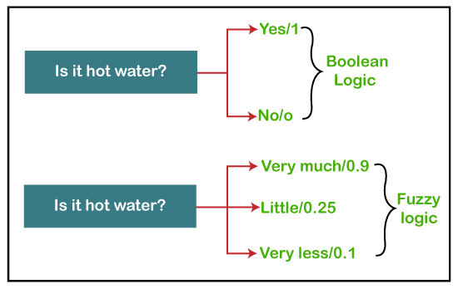

Fuzzy logic contains the multiple logical values and these values are the truth values of a variable or problem between 0 and 1. This concept was introduced by **Lofti Zadeh** in **1965** based on the **Fuzzy Set Theory**. This concept provides the possibilities which are not given by computers, but similar to the range of possibilities generated by humans.

In the Boolean system, only two possibilities (0 and 1) exist, where 1 denotes the absolute truth value and 0 denotes the absolute false value. But in the fuzzy system, there are multiple possibilities present between the 0 and 1, which are partially false and partially true.

Characteristics of Fuzzy Logic

Following are the characteristics of fuzzy logic:

1. This concept is flexible and we can easily understand and implement it.
2. It is used for helping the minimization of the logics created by the human.
3. It is the best method for finding the solution of those problems which are suitable for approximate or uncertain reasoning.
4. In fuzzy logic, everything is a matter of degree.
5. In the Fuzzy logic, any system which is logical can be easily fuzzified.
6. It is based on natural language processing.
7. It is also used by the quantitative analysts for improving their algorithm's execution.
8. It also allows users to integrate with the programming.

## Architecture of a Fuzzy Logic System

In the architecture of the **Fuzzy Logic** system, each component plays an important role. The architecture consists of the different four components which are given below.

1. Rule Base
2. Fuzzification
3. Inference Engine
4. Defuzzification

Following diagram shows the architecture or process of a Fuzzy Logic system:

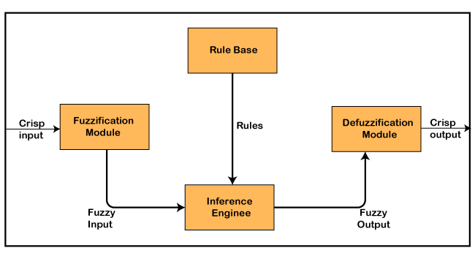

### 1. Rule Base

Rule Base is a component used for storing the set of rules and the If-Then conditions given by the experts are used for controlling the decision-making systems. There are so many updates that come in the Fuzzy theory recently, which offers effective methods for designing and tuning of fuzzy controllers. These updates or developments decreases the number of fuzzy set of rules.

### 2. Fuzzification

**Fuzzification** is a module or component for transforming the system inputs, i.e., it converts the crisp number into fuzzy steps. The crisp numbers are those inputs which are measured by the sensors and then fuzzification passed them into the control systems for further processing. This component divides the input signals into following five states in any Fuzzy Logic system:

* Large Negative(NN)
* Medium Negative (N)
* Small (S)
* Medium Positive (P)
* Large Positive (PP)

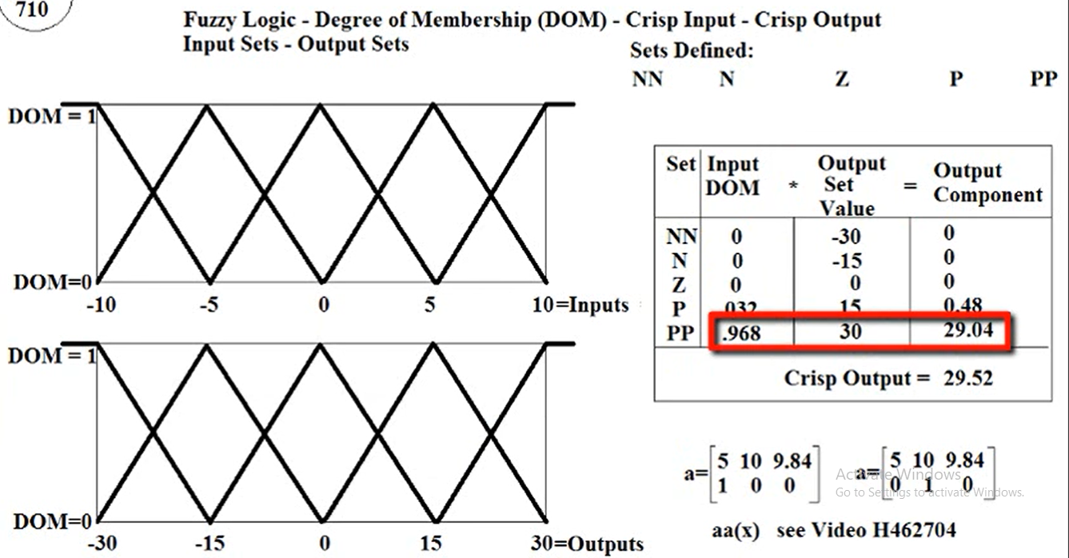

### 3. Inference Engine

This component is a main component in any Fuzzy Logic system (FLS), because all the information is processed in the Inference Engine. It allows users to find the matching degree between the current fuzzy input and the rules. After the matching degree, this system determines which rule is to be added according to the given input field. When all rules are fired, then they are combined for developing the control actions.

### 4. Defuzzification

**Defuzzification** is a module or component, which takes the fuzzy set inputs generated by the **Inference Engine**, and then transforms them into a crisp value.  It is the last step in the process of a fuzzy logic system. The crisp value is a type of value which is acceptable by the user. Various techniques are present to do this, but the user has to select the best one for reducing the errors.

**Topic-8: Introduction to crisp set**

Crisp set is a collection of **unordered distinct**elements, which are derived from Universal set. Universal set consists of all possible elements which take part in any experiment. Set is quite useful and important way of representing data.

Let X represents a set of natural numbers, so

X = {1, 2, 3, 4, …}

Sets are always defined with respect to some universal set. Let us derive two sets A and B from this universal set X.

A = Set of even numbers = {2, 4, 6, …}

B = Set of odd number = {1, 3, 5, …}

Elements in the set are **unique**, i.e. A = {1, 1, 2, 2, 3, 3}, B = {1, 2, 3}, C = {1, 2, 2, 3, 3, 3} all are same.

The best example of crisp set representation is number system in mathematics, where,

* N: Set of natural numbers
* R: Set of real numbers
* Z: Set of integers
* Q: Set of rational numbers

**Notations used in Crisp Set**

We will discuss the various set notations with respect to following sets:

X = {1, 2, 3, 4, 5, 6, 7, 8, 9, 10}  
A = {2, 4, 6, 8, 10}  
B = {1, 3, 5, 7, 9}  
C = {4, 6, 8}  
D = {x | x is perfect square and x > 10} = Φ

Various notations used in set theory are defined below:

* Φ: **Empty set**is represented by the symbol, Φ is a set which does not have any element in it. For given data, D = Φ
* x ∈ A represents element x is **member**of set A. For given data, 2 ∈ A
* x ∉ A represents an element x is **not a member**of set A. For given data, 3 ∉ A
* A ⊆ B represents every element of set A is present in set B as well. In other words, A is **subset**of B. For given data, A ⊆ X
* A ⊇ B represents every element of B is member of set A as well. In other words, A is **superset**of B. For given sets, A ⊇ C
* A ⊂ B represents every element of A is in B as well as B has some additional element which is not in A. This notation says that A is **proper subset**of B.
* A ⊃ B represents all the elements of B are in set A as well as A has some additional element which is not in B. This notation says that A is **proper superset**of B.
* if set A and B are identical then we can say A is subset of B or B is subset of A, but we cannot say that A is proper superset of B or A is proper subset of B
* A = B represents **Equal sets**, i.e. sets A and B have identical elements
* A ≠ B represents **Not equal sets**, i.e. sets A and B have different elements. For given sets, A ≠ B

**Topic-9: Fuzzy Set**

The set theory of classical is the subset of Fuzzy set theory. Fuzzy logic is based on this theory, which is a generalisation of the classical theory of set (i.e., crisp set) introduced by Lofti A. Zadeh in 1965.

A fuzzy set is a collection of values which exist between 0 and 1. Fuzzy sets are denoted or represented by the tilde (~) character. The sets of Fuzzy theory were introduced in 1965 by Lofti A. Zadeh and Dieter Klaua. In the fuzzy set, the partial membership also exists. This theory released as an extension of classical set theory.

This theory is denoted mathematically asA fuzzy set (Ã) is a pair of U and M, where U is the Universe of discourse and M is the membership function which takes on values in the interval [ 0, 1 ]. The universe of discourse (U) is also denoted by Ω or X.

## Fuzzy Logic Tutorial

## Membership Function

**The membership function** is a function which represents the graph of fuzzy sets, and allows users to quantify the linguistic term. It is a graph which is used for mapping each element of x to the value between 0 and 1.

This function is also known as indicator or characteristics function.

This function of Membership was introduced in the first papers of fuzzy set by **Zadeh**. For the Fuzzy set B, the membership function for X is defined as: μB:X → [0,1]. In this function X, each element of set B is mapped to the value between 0 and 1. This is called a degree of membership or membership value.

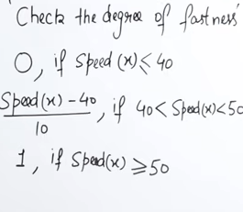dff ff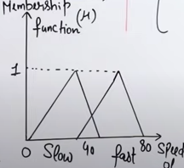

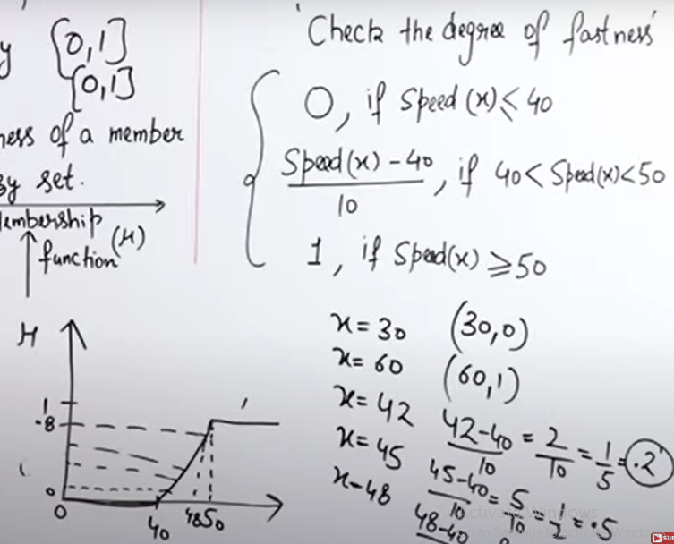

**Operations on Fuzzy Set**

Given Ã and B are the two fuzzy sets, and X be the universe of discourse with the following respective member functions:

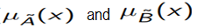

The operations of Fuzzy set are as follows:

|  |  |
| --- | --- |
| **1.Union Operation: μA∪B(x) = max (μA(x), μB(x))**  **EXAMPLE:**  A = {( X1, 0.6 ), (X2, 0.2), (X3, 1), (X4, 0.4)}  B = {( X1, 0.1), (X2, 0.8), (X3, 0), (X4, 0.9)}  AUB = {( X1, 0.6), (X2, 0.8), (X3, 1), (X4, 0.9)}  **Because, according to this operation**  **For X1**  μA∪B(X1) = max (μA(X1), μB(X1)) μA∪B(X1) = max (0.6, 0.1) μA∪B(X1) = 0.6 (same as for X2,X3 AND X4) | |
| 2.**Intersection Operation:μA∩B(x) = min (μA(x), μB(x))**  **Example:**  A = {( X1, 0.3 ), (X2, 0.7), (X3, 0.5), (X4, 0.1)}  B = {( X1, 0.8), (X2, 0.2), (X3, 0.4), (X4, 0.9)}  A∩B = {( X1, 0.3), (X2, 0.2), (X3, 0.4), (X4, 0.1)}  **Because, according to this operation**  **For X1**  μA∩B(X1) = min (μA(X1), μB(X1)) μA∩B(X1) = min (0.3, 0.8) μA∩B(X1) = 0.3  (same as for X2,X3 AND X4) |

|  |
| --- |
| 3.**Complement Operation: μĀ(x) = 1-μA(x),**  **Example:**  Let's suppose A is a set which contains following elements:  A = {( X1, 0.3 ), (X2, 0.8), (X3, 0.5), (X4, 0.1)}  then,  Ā= {( X1, 0.7 ), (X2, 0.2), (X3, 0.5), (X4, 0.9)}  Because, according to this operation  For X1  μĀ(X1) = 1-μA(X1)  μĀ(X1) = 1 - 0.3  μĀ(X1) = 0.7 (same as for X2,X3 AND X4) |

|  |
| --- |
| 4. BOLD UNION:**μA⊕μB(x) = min [1,μA(x)+μB(x)]**  **EXAMPLE:**  A = {( X1, 0.3 ), (X2, 0.7), (X3, 0.5), (X4, 0.1)}  B = {( X1, 0.8), (X2, 0.2), (X3, 0.4), (X4, 0.9)}  **A⊕B**= {( X1, 1), (X2, 0.9), (X3, 0.9), (X4, 1)}  **For X1**  **A⊕B** (X1) = min [1,(μA(X1)+μB(X1)] **A⊕B** (X1) = min [1,(0.3+0.8)] **A⊕B** (X1) = min[1, 1.1] [ min of 1 and 1.1 is 1] (same as for X2,X3 AND X4) |

|  |
| --- |
| 5.BOLD INTERSECTION:Ao B(x)=Max[0,μA(x)+μB(x)-1]  **EXAMPLE**:  A = {( X1, 0.3 ), (X2, 0.7), (X3, 0.5), (X4, 0.1)}  B = {( X1, 0.8), (X2, 0.2), (X3, 0.4), (X4, 0.9)}  **A o B** = {( X1, 0.1), (X2, 0), (X3, 0), (X4, 1)}  **For X1**  **A o B**(X1) =max[0,(μA(X1)+μB(X1)-1] **A o B**(X1) = max [0,(0.3+0.8)-1] **A o B**(X1) = max[0, (1.1-1)]  **A o B**(X1) = max[0, (0.1)] [ max of 0 and 0.1 is 0.1] (same as for X2,X3 AND X4) |

|  |
| --- |
| 6.EQUALITY:A=B if **μA(x)=μB(x)**∀**x € S**  **EXAMPLE:**  **A** = {( X1, 0.3 ), (X2, 0.7), (X3, 0.5), (X4, 0.1)}  B = {( X1, 0.3), (X2, 0.7), (X3, 0.5), (X4, 0.1)}  **A=B** |

|  |  |
| --- | --- |
| **Classical Set Theory** | **Fuzzy Set Theory** |
| 1. This theory is a class of those sets having sharp boundaries. | 1. This theory is a class of those sets having un-sharp boundaries. |
| 2. This set theory is defined by exact boundaries only 0 and 1. | 2. This set theory is defined by ambiguous boundaries. |
| 3. In this theory, there is no uncertainty about the boundary's location of a set. | 3. In this theory, there always exists uncertainty about the boundary's location of a set. |
| 4. This theory is widely used in the design of digital systems. | 4. It is mainly used for fuzzy controllers. |

**Applications of Fuzzy Logic:**

Following are the different application areas where the Fuzzy Logic concept is widely used:

1. It is used in **Businesses** for decision-making support system.
2. It is used in **Automative systems** for controlling the traffic and speed, and for improving the efficiency of automatic transmissions. **Automative systems** also use the shift scheduling method for automatic transmissions.
3. This concept is also used in the **Defence** in various areas. Defence mainly uses the Fuzzy logic systems for underwater target recognition and the automatic target recognition of thermal infrared images.
4. It is also widely used in the **Pattern Recognition and Classification** in the form of Fuzzy logic-based recognition and handwriting recognition. It is also used in the searching of fuzzy images.
5. Fuzzy logic systems also used in **Securities**.
6. It is also used in **microwave oven** for setting the lunes power and cooking strategy.
7. This technique is also used in the area of **modern control systems** such as expert systems.
8. **Finance** is also another application where this concept is used for predicting the stock market, and for managing the funds.
9. It is also used for controlling the brakes.
10. It is also used in the **industries of chemicals** for controlling the ph, and chemical distillation process.
11. It is also used in the **industries of manufacturing** for the optimization of milk and cheese production.
12. It is also used in the vacuum cleaners, and the timings of washing machines.
13. It is also used in heaters, air conditioners, and humidifiers.

**Advantages of Fuzzy Logic:**

Fuzzy Logic has various advantages or benefits. Some of them are as follows:

1. The methodology of this concept works similarly as the human reasoning.
2. Any user can easily understand the structure of Fuzzy Logic.
3. It does not need a large memory, because the algorithms can be easily described with fewer data.
4. It is widely used in all fields of life and easily provides effective solutions to the problems which have high complexity.
5. This concept is based on the set theory of mathematics, so that's why it is simple.
6. It allows users for controlling the control machines and consumer products.
7. The development time of fuzzy logic is short as compared to conventional methods.
8. Due to its flexibility, any user can easily add and delete rules in the FLS system.

**Disadvantages of Fuzzy Logic**

Fuzzy Logic has various disadvantages or limitations. Some of them are as follows:

1. The run time of fuzzy logic systems is slow and takes a long time to produce outputs.
2. Users can understand it easily if they are simple.
3. The possibilities produced by the fuzzy logic system are not always accurate.
4. Many researchers give various ways for solving a given statement using this technique which leads to ambiguity.
5. Fuzzy logics are not suitable for those problems that require high accuracy.
6. The systems of a Fuzzy logic need a lot of testing for verification and validation.

**Topic-10: Fuzzy Logic Control (FLC):**

Assumptions in Fuzzy Logic Control (FLC) Design

While designing fuzzy control system, the following six basic assumptions should be made −

* **The plant is observable and controllable** − It must be assumed that the input, output as well as state variables are available for observation and controlling purpose.
* **Existence of a knowledge body** − It must be assumed that there exist a knowledge body having linguistic rules and a set of input-output data set from which rules can be extracted.
* **Existence of solution** − It must be assumed that there exists a solution.
* **‘Good enough’ solution is enough** − The control engineering must look for ‘good enough’ solution rather than an optimum one.
* **Range of precision** − Fuzzy logic controller must be designed within an acceptable range of precision.
* **Issues regarding stability and optimality** − The issues of stability and optimality must be open in designing Fuzzy logic controller

Architecture of Fuzzy Logic Control

The following diagram shows the architecture of Fuzzy Logic Control (FLC).

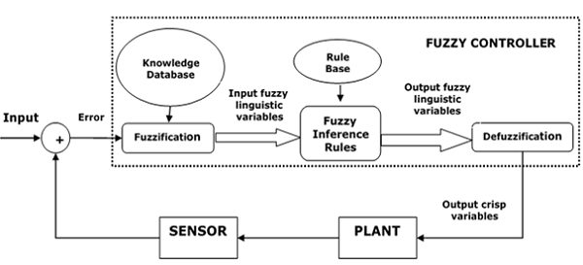

Major Components of FLC

Followings are the major components of the FLC as shown in the above figure −

* **Fuzzifier** − The role of fuzzifier is to convert the crisp input values into fuzzy values.
* **Fuzzy Knowledge Base** − It stores the knowledge about all the input-output fuzzy relationships. It also has the membership function which defines the input variables to the fuzzy rule base and the output variables to the plant under control.
* **Fuzzy Rule Base** − It stores the knowledge about the operation of the process of domain.
* **Inference Engine** − It acts as a kernel of any FLC. Basically it simulates human decisions by performing approximate reasoning.
* **Defuzzifier** − The role of defuzzifier is to convert the fuzzy values into crisp values getting from fuzzy inference engine.

Steps in Designing FLC

* **Identification of variables** − Here, the input, output and state variables must be identified of the plant which is under consideration.
* **Fuzzy subset configuration** − The universe of information is divided into number of fuzzy subsets and each subset is assigned a linguistic label. Always make sure that these fuzzy subsets include all the elements of universe.
* **Obtaining membership function** − Now obtain the membership function for each fuzzy subset that we get in the above step.
* **Fuzzy rule base configuration** − Now formulate the fuzzy rule base by assigning relationship between fuzzy input and output.
* **Fuzzification** − The fuzzification process is initiated in this step.
* **Combining fuzzy outputs** − By applying fuzzy approximate reasoning, locate the fuzzy output and merge them.
* **Defuzzification** − Finally, initiate defuzzification process to form a crisp output.

Advantages of Fuzzy Logic Control

Let us now discuss the advantages of Fuzzy Logic Control.

* **Cheaper** − Developing a FLC is comparatively cheaper than developing model based or other controller in terms of performance.
* **Robust** − FLCs are more robust than PID controllers because of their capability to cover a huge range of operating conditions.
* **Customizable** − FLCs are customizable.
* **Emulate human deductive thinking** − Basically FLC is designed to emulate human deductive thinking, the process people use to infer conclusion from what they know.
* **Reliability** − FLC is more reliable than conventional control system.
* **Efficiency** − Fuzzy logic provides more efficiency when applied in control system.

Disadvantages of Fuzzy Logic Control

We will now discuss what are the disadvantages of Fuzzy Logic Control.

* **Requires lots of data** − FLC needs lots of data to be applied.
* **Needs high human expertise** − This is one drawback as the accuracy of the system depends on the knowledge and expertise of human beings.
* **Needs regular updating of rules** − The rules must be updated with time.

**Topic-11: Fuzzy Inference System**

A fuzzy inference system is a key component of any fuzzy logic system. It uses fuzzy set theory, IF-THEN rules and fuzzy reasoning process to find the output corresponding to crisp inputs. Predicates in IF-THEN rules are connected using and or or logical connectives.

**Characteristics of FIS:**

* Read crisp value from the process
* Maps the crisp value into fuzzy value using the fuzzy membership function
* Apply IF-THEN rules from the fuzzy rule base and compute fuzzy output
* Convert fuzzy output into crisp by applying some defuzzification methods.

**How fuzzy inference system works?**

Crisp input of any process (measuring temperature of air conditioner, measuring altitude, attitude, height, angle of direction for aeroplane etc. ) is given to the fuzzifier, which applies fuzzy membership function and maps the actual readings into fuzzy value (i.e. the value between 0 to 1).

The inference engine applies fuzzy rules from the knowledge base and produces the fuzzy output, which is again between 0 and 1. This output can not be used directly in any process or system. It needs to be mapped into the original domain. Defuzzifier is the inverse process of fuzzification, it converts the fuzzy output into crisp output, which can be fed to the process. Crisp sets are internally converted to fuzzy sets.

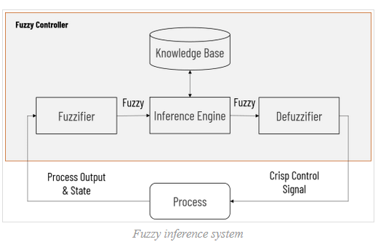

Let’s take the scenario of the air conditioner. For simplicity, we will consider only one parameter which determines the temperature of the air conditioner to be set. Let us consider that the temperature of an air conditioner depends on the parameter called room temperature.

Let us divide the range of room temperature into cool, nominal and warm. Any temperature value may belong to multiple sets with different membership values. The value t = 20 has a membership value of 1 in the nominal set and 0 in the other two. If we move to the right, the membership value in the nominal set decreases and in the warm set, it increases. And as we move left from t = 20, the membership value in the nominal set decreases and in the cool set it increases

Any room temperature is converted to fuzzy value using such fuzzification methods (here we have used triangular membership function, more are discussed later in this article). And that input goes to the inference engine, which will determine what should be the temperature of the air conditioner. Assume that the internal representation of that temperature belongs to the increase and decrease set.

So the generated output might have some membership for both the increase and decrease sets. Assume that it’s 0.7 for increased class and 0.15 for decreased class. Although output is computed, it can not be given directly to the controller of AC, because the controller does not understand what is meaning of the membership value of temperature 0.7 in the increase class and 0.15 in the decrease class.

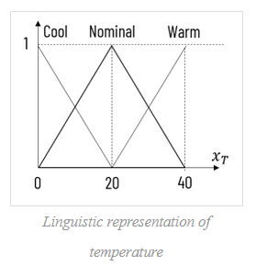

A number of defuzzification methods are there which can be used to convert this fuzzy output into a crisp one. For a particular instance, the crisp output may be -4, which says reducing the temperature of the air conditioner by 4 degrees

**Approaches for Fuzzy Inference System**

1. Mamdani fuzzy inference system
2. Takagi-Sugeno fuzzy inference system

**1. Mamdani Fuzzy Inference System**

In 1975, Professor Ebrahim Mamdani of London University built one of the first fuzzy systems to control a steam engine and boiler combination.

He applied a set of fuzzy rules supplied by experienced human operators.

Mamdani fuzzy inference system operates as follow:

1. Determining a set of fuzzy rules
2. Fuzzifying the inputs using the input membership functions
3. Combining the fuzzified inputs according to the fuzzy rules to establish a rule strength (Fuzzy Operations)
4. Finding the consequence of the rule by combining the rule strength and the output membership function (implication)
5. Combining the consequences to get an output distribution (aggregation)
6. Defuzzifying the output distribution (this step is only if a crisp output (class) is needed).

There are two types of Mamdani fuzzy inference systems:

1. Max-Min inference method
2. Max-Product inference method

## Max-Min Inference Method:

**Example**:

Consider the following rules:

Rule 1: IF x1 is A11 **and** x2 is A21 THEN y1 is B1

Rule 2: IF x1 is A12 **or** x2 is A22 THEN y2 is B2

let us compute the output for x1 = 2.5 and x2 = 3

Membership functions for given rules are shown below:

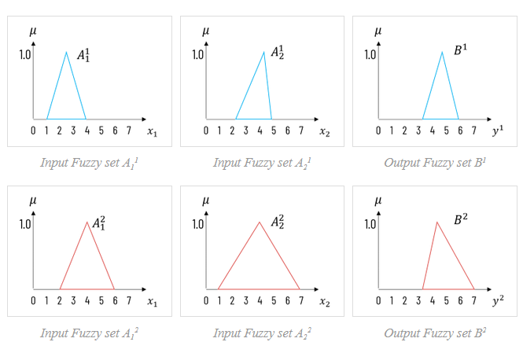

The fuzzy value corresponding to x1 and x2 in both input fuzzy sets is shown in the following figure. Its corresponding membership in the output function is also depicted. As it is a Max-Min inference method, the highest membership value from two input sets is assigned to the corresponding output set.

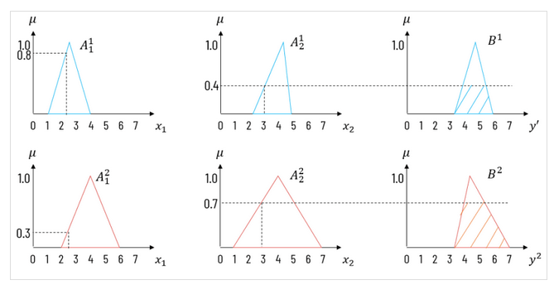

For the first rule, the fuzzy membership value for x1 would be 0.8 and for x2 it would be 0.4. Propositions in the first IF-THEN rule are connected using **and** connective. So we have to take the intersection of fuzzy values, which returns the minimum of them. So the output y1 will have membership 0.4 in the fuzzy output set B1.

For the second rule, the fuzzy membership value for x1 would be 0.3 and for x2 it would be 0.7. Propositions in the second IF-THEN rule are connected using **or** connective. So we have to take the union of fuzzy values, which returns a maximum of them. So the output y2 will have membership 0.7 in the fuzzy output set B2.

To compute the final crisp output, we shall aggregate the fuzzy output functions as shown in the figure.

We can apply any defuzzification technique as discussed earlier to find the final crisp output for given case.

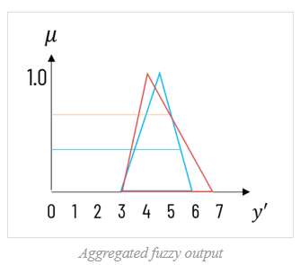

**2. Takagi-Sugeno Fuzzy Model (TS Method)**

This model was proposed by Takagi, Sugeno and Kang in 1985. Format of this rule is given as −

*IF x is A and y is B THEN Z = f(x,y)*

Here, *AB* are fuzzy sets in antecedents and *z = f(x,y)* is a crisp function in the consequent.

Fuzzy Inference Process

The fuzzy inference process under Takagi-Sugeno Fuzzy Model (TS Method) works in the following way −

* **Step 1: Fuzzifying the inputs** − Here, the inputs of the system are made fuzzy.
* **Step 2: Applying the fuzzy operator** − In this step, the fuzzy operators must be applied to get the output.

Rule Format of the Sugeno Form

The rule format of Sugeno form is given by −

*if 7 = x and 9 = y then output is z = ax+by+c*

**Topic-12: PLANNING WITH STATE SPACE SEARCH**

Inroduction:

* 1. The difficulties of problem solving agents like irrelevant actions,finding a good heuristic function andproblem decomposition are rectified by using Planning problem solving agents
  2. These planning problems represents states,actions and goals-finds a language that is expressive enough to describe a wide variety of problems,but restrictive enough to allow efficient algorithm to operate over it.
  3. The languages of planning problems are: (i)STRIPS(Stanford Research Institute Problem Solver)and (ii)ADL(Action Description Language).

Example of Planning Problems:(i)Air Cargo Problem

(ii)Spare Tire Problem

Planning with state space search: It is a straight-forward planning algorithm which perform searching in following ways:

1. Forward state space search algorithm

2.Backward state space search algorithm

3. Heuristic for state space search

1. **Forward state space search algorithm**:

I) It is also called as progression planning, because it moves in the forward direction

II) The formulation of planning problems as state-space search problems is as follows:

* 1. The initial state of the search is the initial state from the planning problem
  2. The actions that are applicable to a state are all those whose preconditions are satisfied
  3. The goalstate checks whether the state satisfies the goal of the planning problem
  4. The step cost of each action is typically 1.

III) Any graph search algorithm that is complete will be a complete planning algorithm

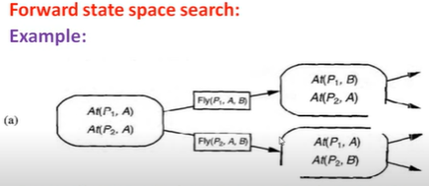

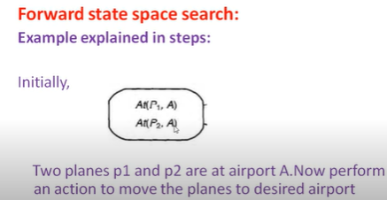

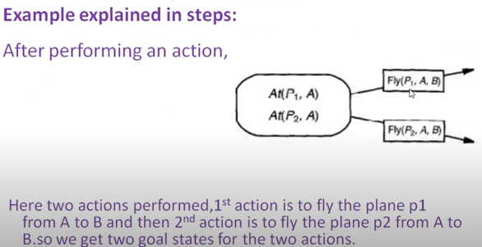

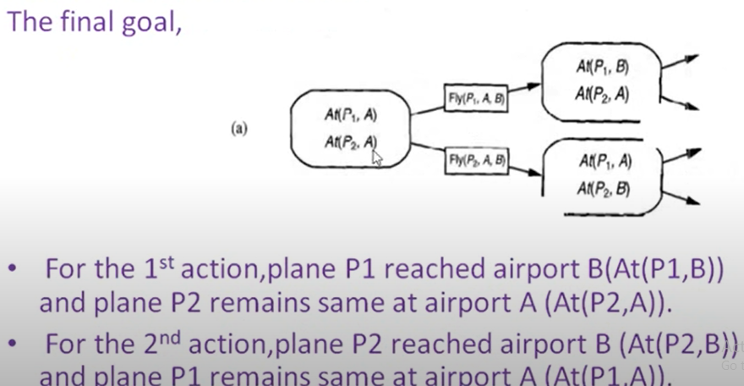

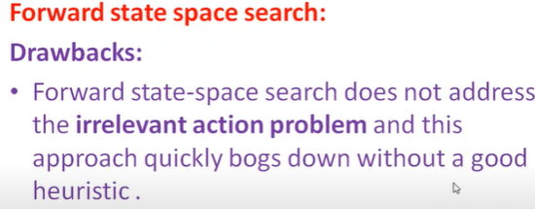

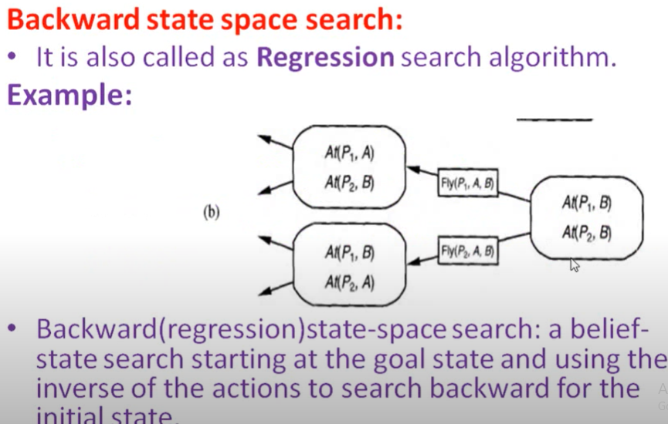

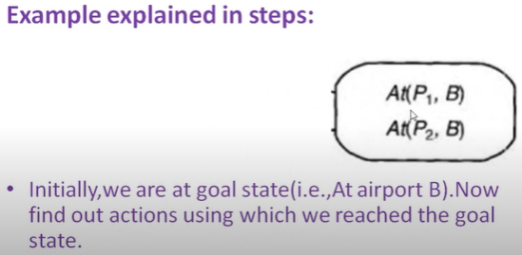

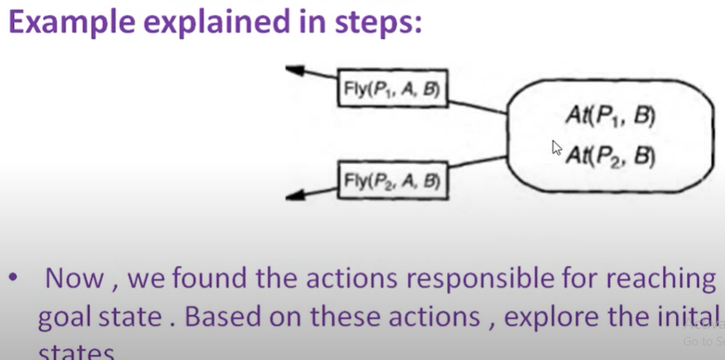

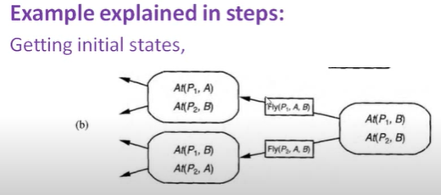

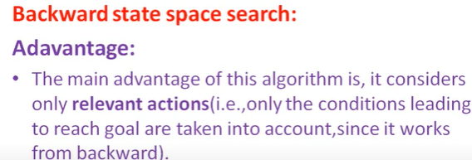

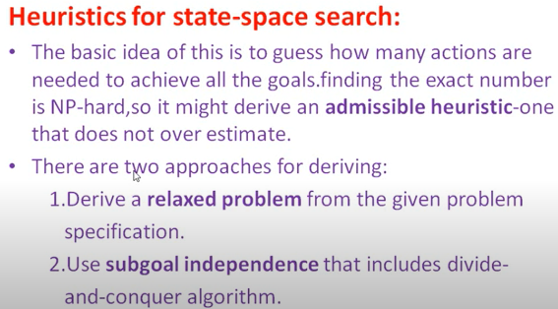

**Topic-13: Partial Order Planning**

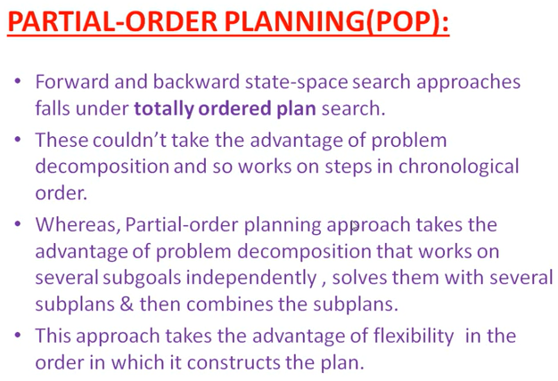

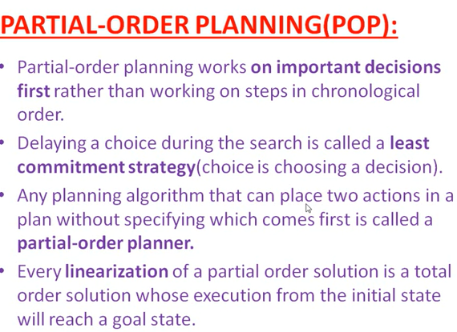

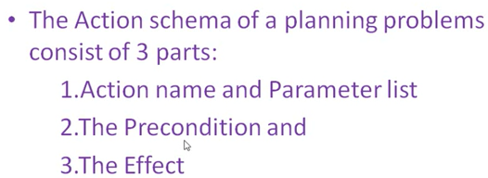

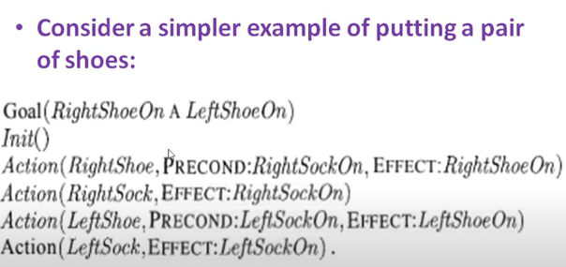

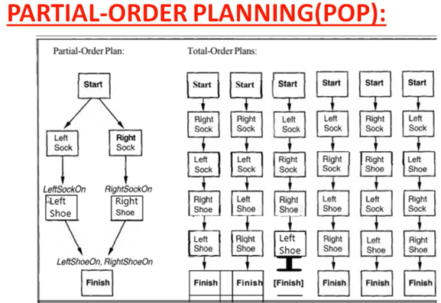

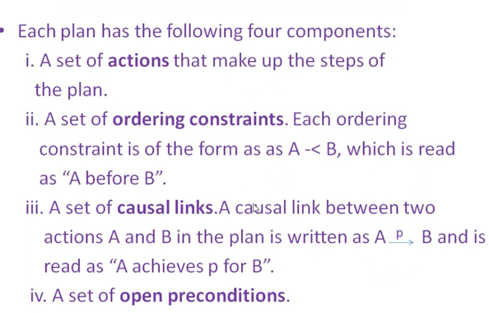

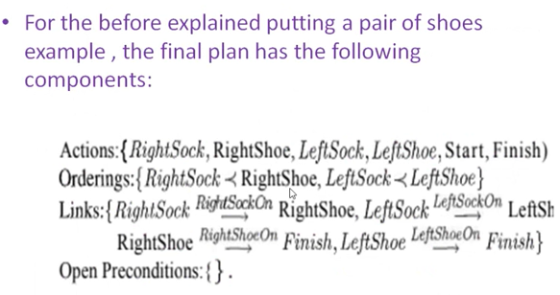

**Topic-14: Planning Graphs**

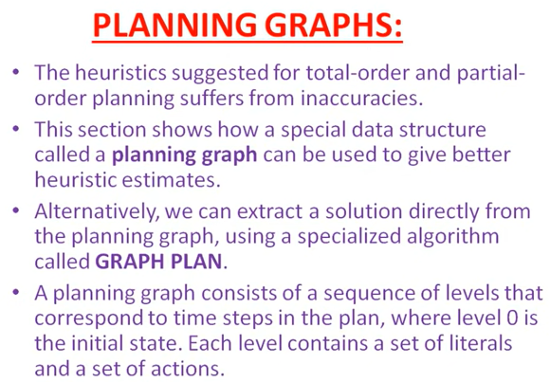

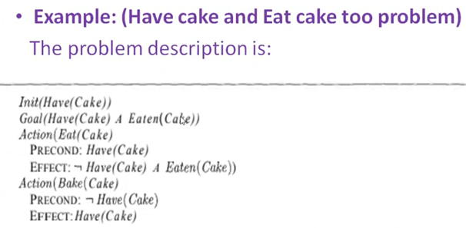

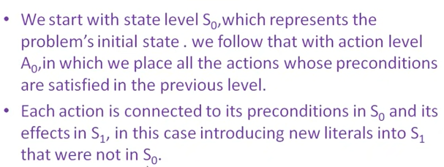

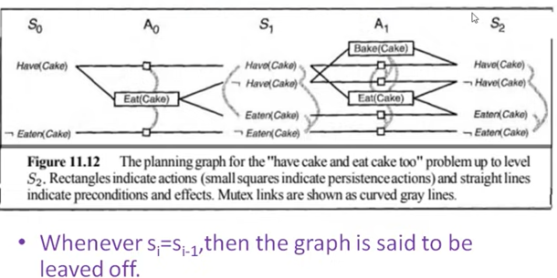

With **Persistence actions**,**Literals always move to the next state**

**Mutex:**The happening OF one action which effects the happening of another action

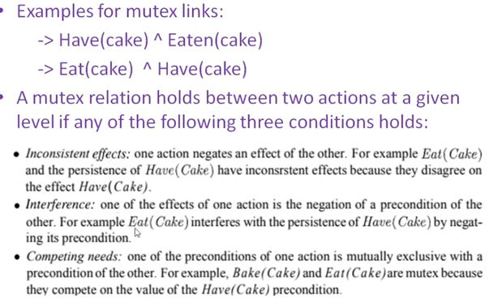

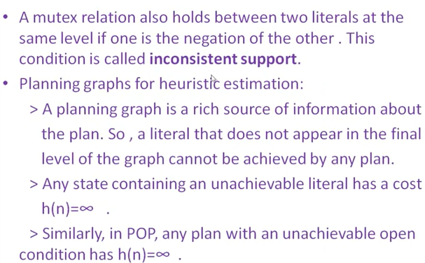

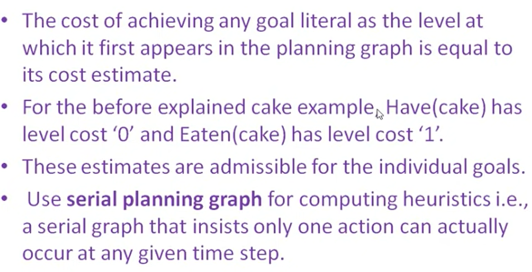

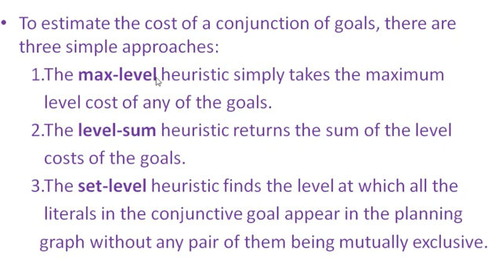

Example for Max level: goal a ^ ~b ^ c ^ ~d ^ ~e

Max(3, 2 , 2, 0 , 1)=3

Sum Level: Assume sub goal independence ie 3+2+2+0+1=8

Set-level: no two sub goals are mutex to each other (takes the level num where no mutex occur)

**Graph plan algorithm**

1. Make a plan graph of depth k

2. Search for a solution

3. If succeed, return a plan

4. Else k=k+1

5. Go to 1.

**Plan Depth**

A plan of depth k

• has k times steps

• may have multiple parallel actions per time step

t = 1 DoADoB

t = 2 DoD

t = 3 DoC DoE

This is a depth three five-step plan. So if you could actually execute these things in parallel, then it would only take you three time steps. If you have to linearize them, it's OK, and you could put DoA and DoB in any order and DoD and DoE in any order. So the algorithm will search for a depth one plan and then a depth two plan and then a depth three plan and so on, until we find the answer. It’s a little like iterative deepening.

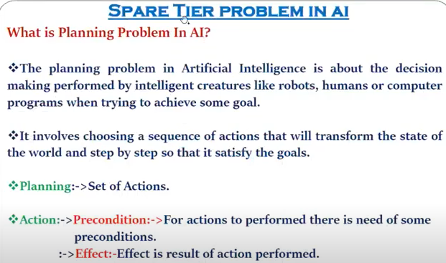

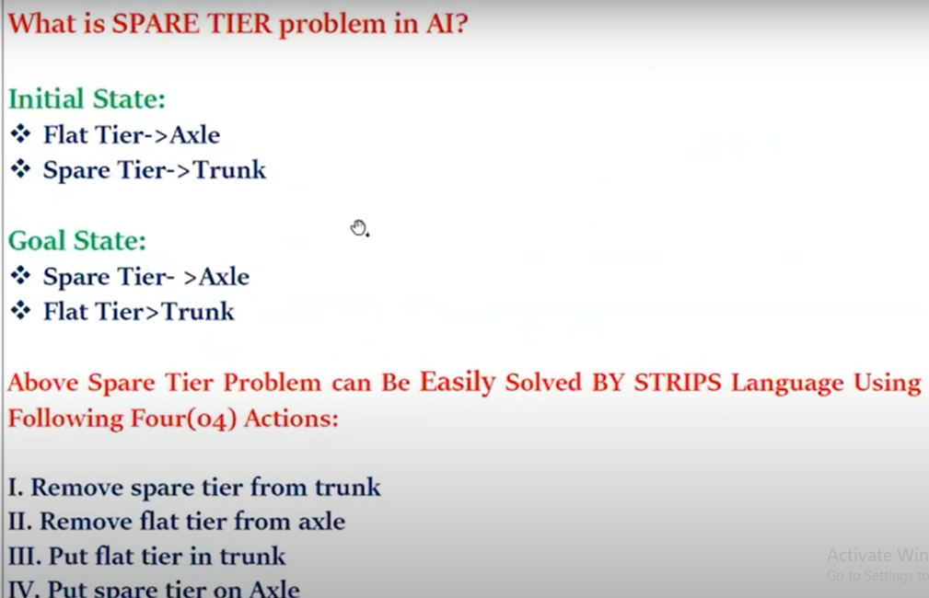

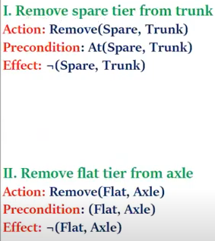

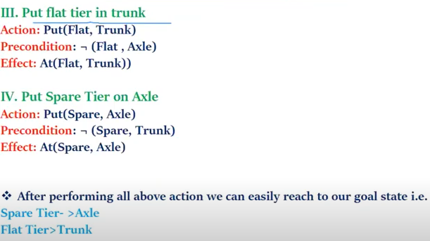

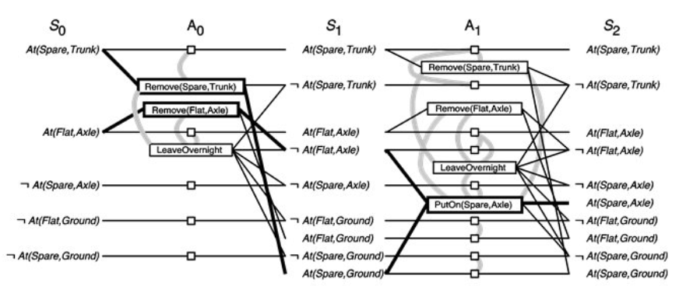

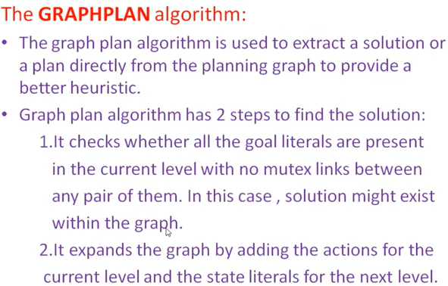

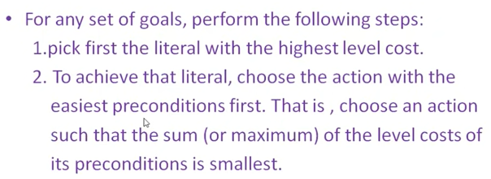

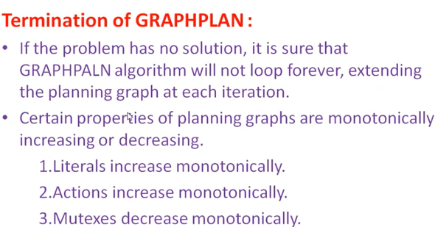

**Topic-15: Planning and Acting in the Real World**

